Math 4 Honors Name ______________________________

Lesson 5-6: *Recursive & Explicit Rules for Sequences* Date ____________________________

**Learning Goals:**

* *I can find terms of a sequence which is defined recursively or explicitly.*
* *I can write explicit and recursive rules for sequences.*
* *I can use the explicit and recursive rules to solve problems.*

I. Many patterns are found within Pascal’s Triangle. Identify the following sequences within each triangle & describe where they occur within Pascal’s Triangle:

1. Natural numbers: 1, 2, 3, 4, ... 2. Powers of 2

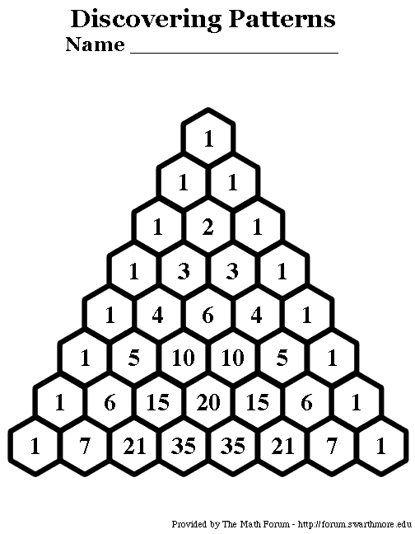

3. Powers of 11 4. Triangular numbers: 1, 3, 6, 10, …



5. Tetrahedral numbers: 1, 4, 10, 20, … 6. Fibonacci numbers: 1, 1, 2, 3, 5, …



OVER 🡪

Page 2

II. The patterns you identified within Pascal’s Triangle are examples of sequences. A **sequence** is an ordered list of values (finite or infinite). Formally, an *infinite* sequence is a function whose domain is the set of natural numbers {1, 2, 3, 4, 5...}, and a *finite* sequence with *n* terms is a function whose domain is the set {1, 2, 3,..., *n*}. This means that you can talk about the 1st element (or term) in a sequence or the 10th element in a sequence or the 101st element in a sequence.

There are two *special* types of sequences:

1. **Arithmetic** 2. **Geometric**

Describe what an arithmetic sequence is. Describe what a geometric sequence is.

Identify an arithmetic sequence from the Identify two geometric sequences from the

front of this investigation. front of this investigation.

What is the *initial term*, denoted *a*1? What is the *initial term*, denoted *a*1 for each?

What is the *common difference*, *d*? What is the *common ratio*, *r*, for each?

III. Sequences can be represented either **recursively** or **explicitly**.

A **recursive formula** is a formula that requires the *computation of all previous terms* in order to find the value of *an*. An **explicit formula** allows *direct computation* of any term.

1. A **recursive rule** for a sequence contains two statements as follows:
2. The *initial condition –* States one or more initial terms
3. The *recurrence relation –* Defines each subsequent term in the sequence by the previous term

The natural numbers are defined recursively as follows. *Pay attention to the notation.*

*a*1 = 1

*ak*+1 = *ak* + 1, *k* > 1

i. Write the recursive rule for the following sequence: 10, 16, 22, 28, …

ii. Write the recursive rule for the powers of 11.

Page 3

1. An **explicit formula** is one statement that for each term, including the first one, is defined in terms of its position in the sequence.

*Arithmetic Rule:* *Geometric Rule:*

*an* = *a*1 + (*n* – 1)*d* *gn*= *g*1**·** *r* *n* – 1

1. Write the explicit rule for the following sequence: 10, 16, 22, 28, …

(Simplify your final formula.)

What type of function does the formula appear to be?

Use your rule to calculate *a*102. _______________

1. Write the explicit rule for the following sequence: 600, 150, 37.5, 9.375, …

(Simplify your final formula – write it in terms of just *n.*)

What type of function does the formula appear to be?

Use your rule to calculate *a*10. _______________

IV. Finding recursive and explicit formulas for sequences:

1. Steps for converting from **explicit to recursive**:
2. Find *a*1. (Provides the *initial condition*)
3. Find *an*+1 (Replace *n* with  *n* + 1)
4. Replace the expression with *an* from the original explicit formula. (Provides the *recurrence relation*)
5. Write your final recursive rule in the form of:

*a*1 =

*an*+1 = , *n* > 1

*How can you verify that you have the correct rule?* OVER 🡪

Page 4

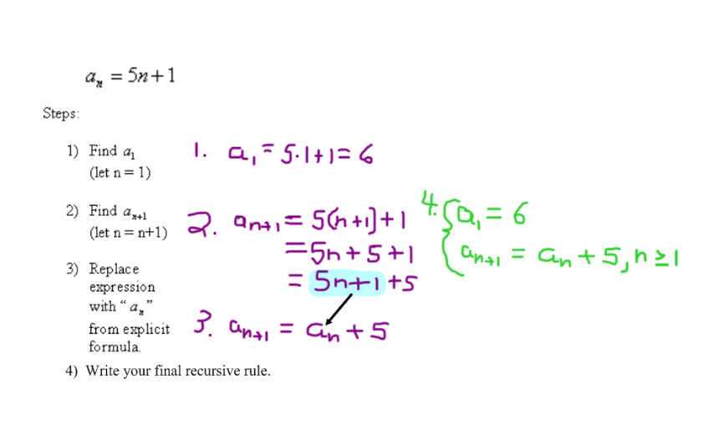 Example:

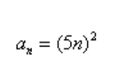

Now you try:

***Hint – Write the rule without parentheses first.

1. Steps for converting from **recursive to explicit**:
2. Generate the first 5 terms of the sequence.
3. Check to see if it is arithmetic or geometric.
4. Use a formula if possible; otherwise do a regression in your calculator . . . .

*How can you verify that you have the correct rule?*

Examples:

i. Find the explicit rule for the Triangular numbers. Write your final rule in factored form.

ii. Find an explicit rule for *Sn*, the sum of the first *n* odd integers.

Math 4 Honors Name ______________________________

Lesson 5-6 Homework Date _____________________________

1. Write the first five terms of an arithmetic sequence with initial term 3 and common difference 4.

1. Write a recursive formula for this sequence. b. Write an explicit formula for this sequence.

2. Write the first five terms of an geometric sequence with initial term 3 and common ratio 4.

1. Write a recursive formula for this sequence. b. Write an explicit formula for this sequence.

3. Find the first five terms of each sequence defined by the given formula. Then determine if the sequence is arithmetic, geometric or neither.





1. b.

c.  d. d.

Note: These are variations of the greatest integer function. The first is called the floor function & the second the ceiling function.



Which rules are explicit rules? OVER 🡪

4. Find recursive rules for the following sequences.

1.  b. 

c. The Fibonacci Sequence

***Hint: Use #3c as your guide.

5. Find explicit rules for the following sequences.

1.  b. 

c. The Tetrahedral numbers; Write your final formula in factored form.